1. **OBJECTIVE :**

This focusses on building, programming an automatic dustbin using sensors and demonstrating an understanding of basic electronics, programming, and environmental awareness.

1. **MATERIALS :**

•Male-Female jumper wire

•Male-Male jumper wire

•Servo motor

•Ultrasonic sensor

•Arduino Uno

•Dustbin

1. **PROCEDURE:**
2. Prepare the Dustbin:

Choose a dustbin with a lid that can be easily moved by a servo motor. Create a small hole near the top edge of the dustbin for the ultrasonic sensor.

1. Set Up the Components:

Ultrasonic Sensor:

Connect the VCC pin to the 5V pin on the Arduino.

Connect the GND pin to the GND pin on the Arduino.

Connect the Trig pin to digital pin 9 on the Arduino.

Connect the Echo pin to digital pin 10 on the Arduino.

Servo Motor:

Connect the control wire (usually orange or white) to digital pin 11 on the Arduino.

Connect the power wire (usually red) to the 5V pin on the Arduino.

Connect the ground wire (usually brown or black) to the GND pin on the Arduino.

3. Write the Arduino Code:

Open the Arduino IDE and write the following code:

#include <Servo.h>

Servo myservo;

const int trigPin = 9;

const int echoPin = 10;

const int servoPin = 11;

long duration;

int distance;

void setup() {

pinMode(trigPin, OUTPUT);

pinMode(echoPin, INPUT);

myservo.attach(servoPin);

myservo.write(0); // Ensure the lid is initially closed

Serial.begin(9600);

}

void loop() {

digitalWrite(trigPin, LOW);

delayMicroseconds(2);

digitalWrite(trigPin, HIGH);

delayMicroseconds(10);

digitalWrite(trigPin, LOW);

duration = pulseIn(echoPin, HIGH);

distance = duration * 0.034 / 2;

if (distance < 30) {

myservo.write(90); // Open the lid

delay(5000); // Keep it open for 5 seconds

myservo.write(0); // Close the lid

}

delay(500); // Check the distance every half

a second

}

4. Upload the Code:

Connect your Arduino to your computer via USB. Select the correct board and port from the Tools menu in the Arduino IDE. Upload the code to the Arduino.

5. Assemble the Circuit:

Place the ultrasonic sensor into the hole made in the dustbin. Mount the servo motor in a position where it can easily open and close the lid. You might need to create a mechanism or linkage that connects the servo horn to the lid. Connect all the jumper wires according to the connections specified in the code.

6. Power the Setup:

Power the Arduino using a USB cable connected to a power bank or a suitable battery pack if you need it to be portable. Alternatively, use a wall adapter if the dustbin will remain stationary.

7. Test the Automatic Dustbin:

Place your hand or an object near the sensor to test if the lid opens and closes automatically. Adjust the delay and distance values in the code if necessary to improve responsiveness.

1. **SCHEMATIC DIAGRAM:**

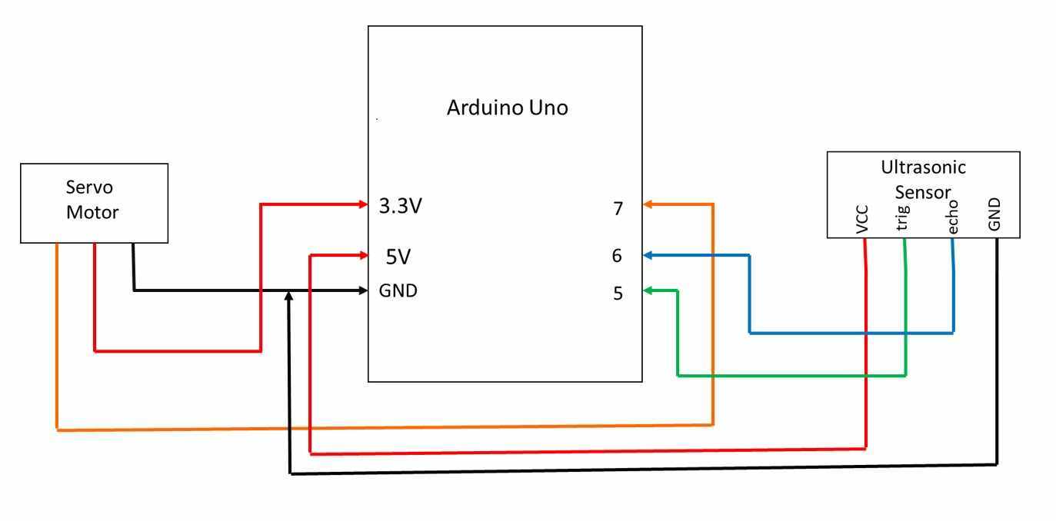

1. **DOCUMENTATION:** 